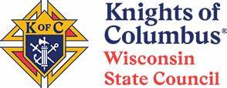

Your DD Reminder List of Stuff to Know / Things To Do

This email has a plethora of topics to address with your councils, including:

FIRE CHECKS from the State Council Charity Fund
Free Throw (and Essay Contest) - "Green Cards" for contestants
DD's - Please send in your Expense Reports to the State Office
District Deputies Attending the State Convention
Help Your Councils get their Nominating Committee Going
State Raffle Tickets Sales Need to be Turned In

Also, the Tootsie Rolls are being ordered and will soon be delivered to the drop sites around the state. Please be prepared to help your councils get their Tootsie Rolls on time. Thanks for your help!

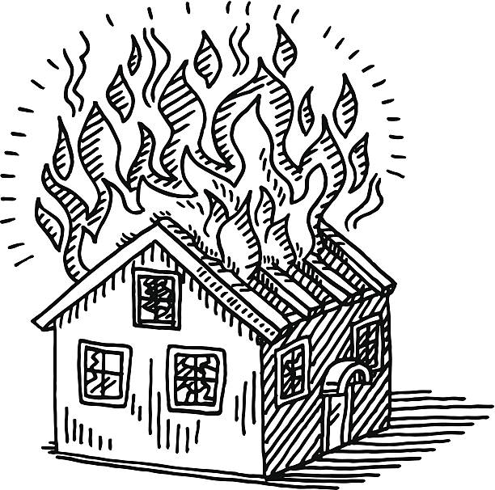  The FIRE CHECK is sent to the Council member who made the request, or to the Grand Knight. | FIRE CHECKS are a Tremendous Help for  ﻿Those in Need!  From February 4th through February 23rd, the State Council wrote and sent out SIXTEEN checks for Fire Victims; we are happy to be of help for those people in need.  They do NOT have to be KC members or even Catholic. There is no form to fill out - just contact Administrative Manager Rick Raulin at the State Office and he will send out an email detailing what information he needs from your Council members.

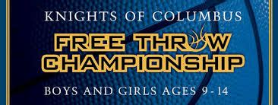  Free Throw Contest  Players NEED to Fill Out a "Green Card" to Compete  We're running out of time to get our Councils to hold their Council-level Free Throw contest (and Essay Contest as well). Each contestant needs to complete a "Green Card" to have their contact information and their parents' or guardians' permission to compete.  If you need "Green Cards" to distribute, we have them at the State Office (4297 West Beltline Hwy, Madison, WI 53711).  We can also mail them to you - just email Admin Manager Rick Raulin with your request and he'll mail them out quickly.    DISTRICT DEPUTIES  Attending State Convention  District Deputies are welcome to attend the State Convention (May 15th - 17th at the Madison Marriott West), but they often have to do it on their own dime. There is nothing in the State Council's budget to send DDs to the State Convention.  Often, DD's may already be attending as a delegate or alternate from their council, or in some other capacity that they are serving in a second position that is supposed to be in attendance.  If that situation is NOT YOU, when you are a District Deputy, it is a tradition (not mandatory) for your District's councils to chip in a donation to send you to convention. It never hurts to ask your own council and others in your district to help you out... Lord knows you give of your time, talent and treasure to serve as a DD. "Ask and it shall be given unto you."﻿ | 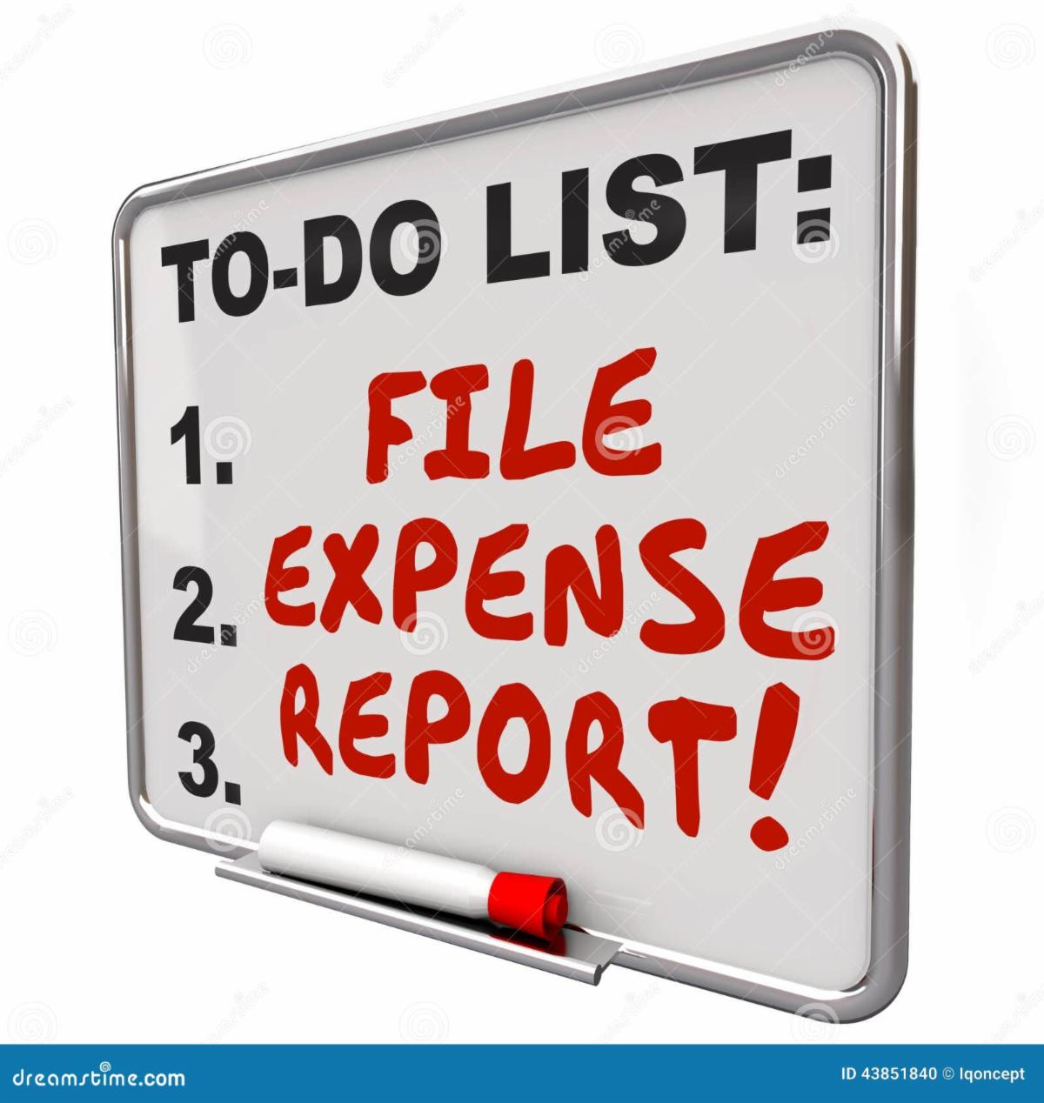  As a District Deputy, you are entitled to get many of your expenses reimbursed, but that does not happen unless YOU send in the appropriate Expense Report.  For your travel to your councils (and approved expenses), the reimbursement comes from SUPREME, so you must use the expense report form from Supreme; here is the link to get to the form.  If your travels take you OUT of your district, such as picking up Tootsie Rolls or delivering them outside of the district, or attending the Diocesan Mtg in another district, the State Council will be reimbursing you and you need to send in the State Expense Report Form. Click HERE to get the link to the form on the State website.  Please send in your Expense Reports at least every quarter, or more often as you need to. Thanks in advance for your help!  Rick Raulin  Elections Are Coming!!  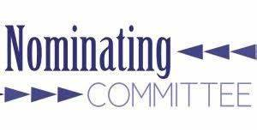  Your councils should be getting their Slate of Officers ready for presentation and voting by their council members in May, so they can get installed in office in June and take their office on July 1st.  Please help them get their slate done!

Get Your Councils to turn in their State Raffle Tickets in Installments  Have your councils been sending in the State Raffle ticket stubs and a check for those tickets sold? They need to be sent to the State Charity Committee representative for their Diocese.  Please encourage your councils to send in a February or March Installment, then an April Installment, so the committee doesn't get a few $100K in stubs and monies at the State Convention.  The council needs to fill out the Council Raffle Deposit Form, after counting the number of ticket stubs and sending along a council check for the correct amount, made out to "WI State KC Charity Fund." | 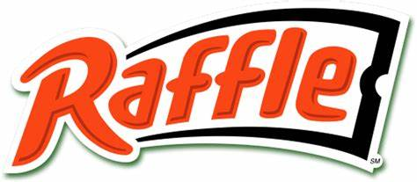  Green Bay Diocese:  JEFF JANSSEN  La Crosse Diocese:  MICHAEL HAIGHT  Madison Diocese:  BOB PIZUR  Milwaukee Archdiocese:  JIM TENPAS  ﻿  Superior Diocese:  DENNIS BERENDS

